//following data effectively
Arul Kumar
Anand
Bala
Chandra Kumar

Program
import java.util.Arrays;
class jagged
{
public static void main(String[]arg)
{
char n[][]=new char [4][];
n[0]=new char[]{'A','r','u','l','k','u','m','a','r'};
n[1]=new char[]{'a','n','a','n','d'};
n[2]=new char[]{'b','a','l','a'};
n[3]=new char[]{'c','h','a','n','d','r','a','k','u','m','a','r'};
for(int i=0;i<n.length;i++)
{
System.out.println(Arrays.toString(n[i]));
}
}
}
Output
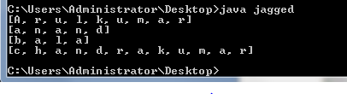

// Program to 2-D jagged array in Java
class Jagged
{
public static void main(String[] args)
{
int arr[][] = new int[2][];

arr[0] = new int[3];

arr[1] = new int[2];

int count = 0;
for (int i=0; i<arr.length; i++)
for(int j=0; j<arr[i].length; j++)
arr[i][j] = count++;
for (int i=0; i<arr.length; i++)
{
for (int j=0; j<arr[i].length; j++)
System.out.print(arr[i][j] + " ");
System.out.println();
}
}
}

Output
0 1 2
3 4

